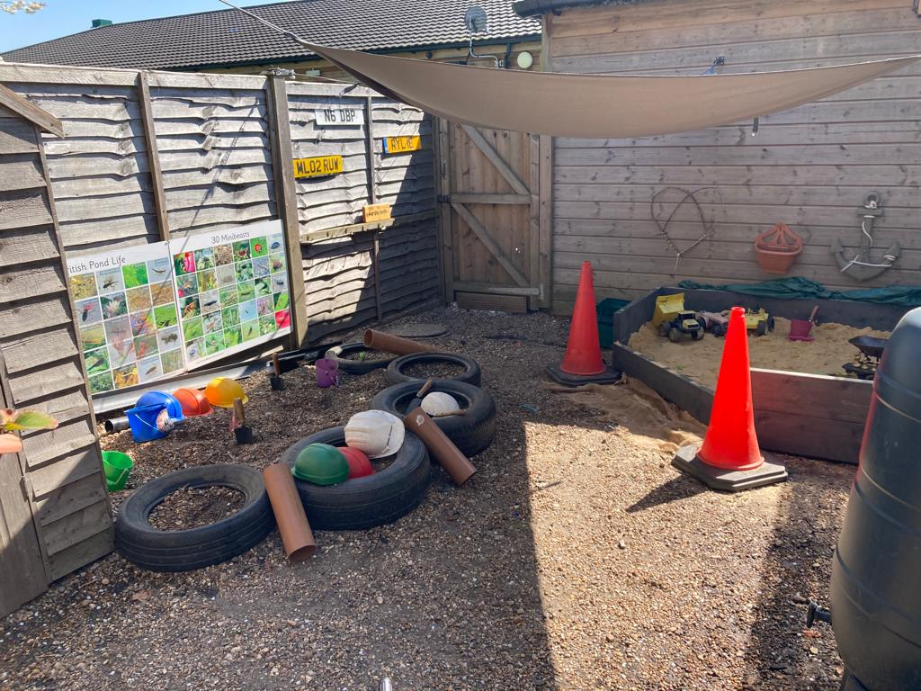
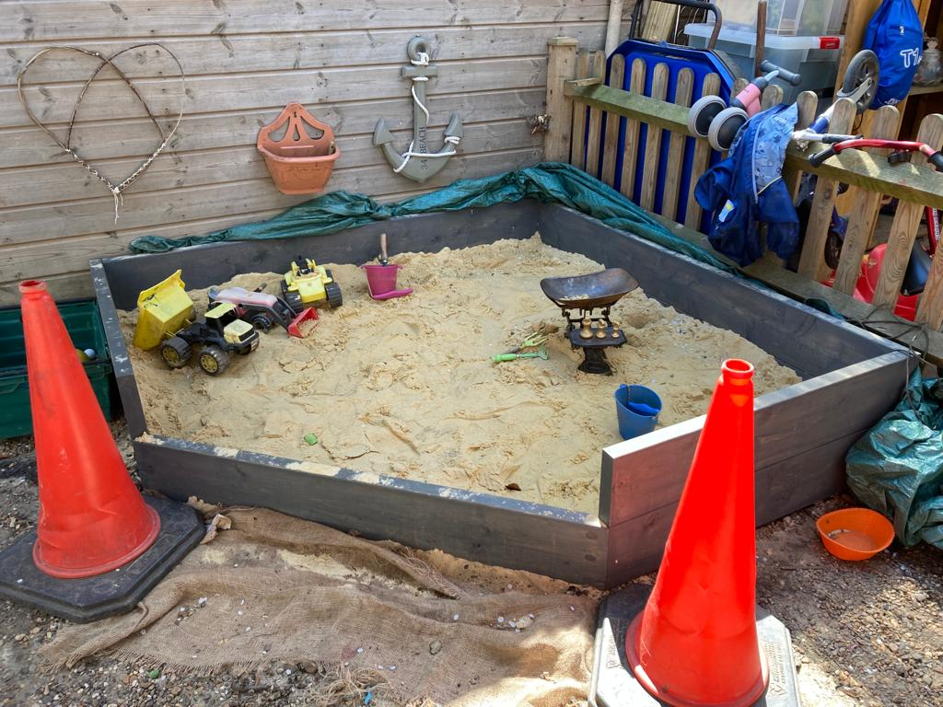
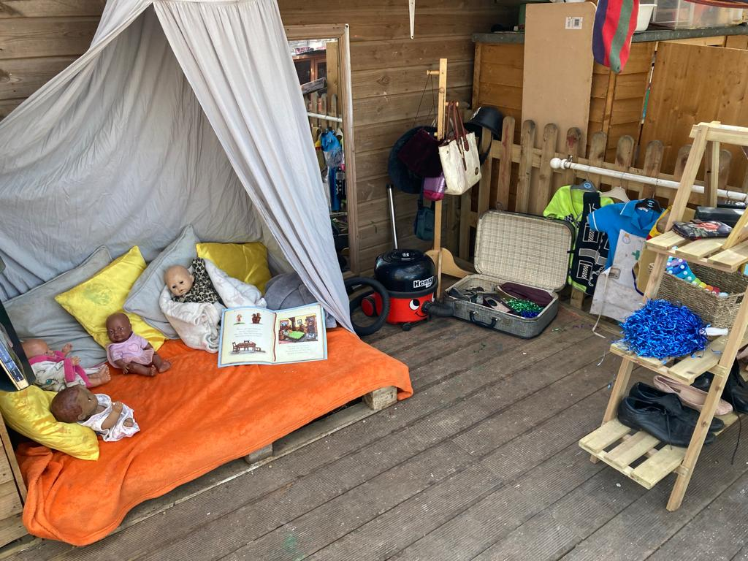
Welcome

Care4kids Childcare Newsletter
  - January 2023
Firstly, a big warm welcome to all our new Caterpillars and Butterflies that are joining us this September! And of course, welcome back to all our families returning after the Summer Holidays. We hope you have all enjoyed the lovely weather.

Diary dates
Please join our Facebook group for parents.
Care4kids Childcare
Start of Term 1 – Monday 5th September
End of Term 1 – Friday 21st October
Start of Term 2 – 🕷 Monday 31st October 🎃
End of Term 2 – Friday 16th December
Start of Term 3 – Tuesday 3rd January (Wednesday 9th for funded children)
End of Term 3 – Friday 10th February
Start of Term 4 – Monday 20th February
End of Term 4 – Friday 31st March
Start of Term 5 – Monday 17th April
End of Term 5 – Friday 25th May
Start of Term 6 – Monday 5th June
End of Term 6 – Monday 24th July (For funded children who attend Mondays only)

SPECIAL EVENTS 2022/2023
Chinese New Year – January 22nd
Valentines Day – February 14th

What to bring to nursery?
As the weather is getting very wet and muddy, please could children make sure they have a waterproof coat and wellie boots. We do try to get the children out as much as possible so please make sure they come in with appropriate clothing and some spare clothes.
FOREST SCHOOL
Forest School has been such a big hit with the children, we will continue this term on a Monday again. We will continue to rotate children and the days we do Forest School so everyone has the opportunity.
FOREST SCHOOL CHECKLIST
Waterproof coat and trousers
Spare clothing
Bottle of water
Hat and gloves

CHINESE NEW YEAR

This year Chinese New Year starts on January 22nd, the festival will last for 15 days ending on the February 5th. Throughout that week we will be discovering and exploring the Chinese New Year festival.

Is your child eligible for Free education or childcare for 2-year-olds?
You can check here https://www.gov.uk/help-with-childcare-costs/free-childcare-2-year-olds

Is your child eligible for 30 hours free childcare for 3-and 4-year olds?
You can check here https://www.gov.uk/30-hours-free-childcare?step-by-step-nav=f517cd57-3c18-4bb9-aa8b-1b907e279bf9

Nursery contact numbers
01233 712712
07888755103 (Butterflies)
07942297199 (Caterpillars)

Care4kids Childcare emails:

Manager: Stacey stacey@care4kidschildcare.co.uk
Senco: Amber Amber@care4kidschildcare.co.uk
Admin and general enquiries: Ellie enquiries@care4kidschildcare.co.uk
Rachelle: Rachelle@care4kidschildcare.co.uk

